Escape From Hellspawn - Storyline Document

**Toronto Metropolitan University**

**Course: CCPS406 - Intro to Software Engineering - P2022**

**Student Names: Jay Sharma, Dryden Zarate, Clement Zhang**

**Date: May 5, 2022**

## Summary of the Game World / Theme

* Our game takes place at a local high school in a peaceful rural community. It’s the first day of school and our main character (MC) is a grade 9 student who finds themself lost, looking for their classroom 102. MC eventually locates their class and, shortly after announcements, violence comes running in their hallways, banging, and yelling at their doors, for unbeknownst to this school, something frightening has been spreading causing the recently dead to violently seek out and consume the living. MC's class barricades themselves and hides waiting for help to arrive! MC hides in a large filing cabinet and, sadly, after the mayhem later finds themselves alone in their classroom. MC must escape from this hell before it is too late...

## Player Goals / Obstacles / Summary of Process to Reach Goal

* The game will explicitly tell the player to use the help command if they would like to see what command options are available. Among the options in the help menu are "backstory". Selecting this option tells the player about the setting of the game.
* During the past few months, there have been news reports of large numbers of people acting strangely. These people are irritable and become liable to physically aggressive behavior when irritated. In addition, there has been a noticeable increase in the amount of internet blogs complaining about their friend (who just happens to have visited their doctor recently) suddenly becoming very rude, more than usual. Experts have dismissed this trend as a coincidence. But the number of people reporting greater irritation than usual has been continuing to climb higher and higher. In addition, during the second month of this trend, those who have been prescribed psychiatric drugs have reported no change in their mood, and city morgues have reported self-moving behavior in corpses but have been able to terminate the self-movement by beheading them. There has been no news from remote town and rural morgues. Possible links between these self-moving corpses and the irritability trend have been claimed by various people, but experts have not confirmed anything yet. For now, out of concerns for national work productivity, work has commenced on attempting to produce a new suppressant for the strangely resistant mental disorder, now called hyper-irritation.
* The objective is to get out of the school using any one of several paths. Options include sneaking out with the key item (otherwise bad ending), fighting one's way out, and defecting to the villain’s side (bad ending). The player will gain access to these options by killing enemies, negotiating with NPCs, and solving various puzzles.
* Achievements such as least number of phrases taken, least number of attacks to force one's way out, etc. will also be added.

## NPCs and their Motivations

* **Injured Janitor (Tobias)** - He was attacked by the zombie king, and it resulted in serious injuries, but thankfully he was able to escape without being infected. He can be found lying on a bed in the Infirmary, with the school nurse also hiding out there with him. After sneakily observing the zombie king, the player will find it odd that a normal person could somehow escape from something that strong. The player can then try to press on it, and he’ll admit to being a guardian against those trying to find an extremely powerful item sealed under the school. He will explain more as the game goes on and sow the seeds of suspicion against everyone else as anyone could be the culprit. Feeling a bit inadequate having to leave everything to the young MC, he does his best to offer some hints when the player doesn’t know what to do next.
* **Occult-Obsessed Student (Matthew)** - Ran straight to his clubroom when he realized that a zombie outbreak had occurred. The player can find him in a small room where his Occult-club hangs out after school. Inherently a coward, he’s terrified of what’s going on and willing to open the door to the MC in return for protection but refuses to leave the room. Scared that he has nothing to offer in return for the player’s company and protection, he offers to use his knowledge to create special items effective against the supernatural based on his research (e.g., consumable talismans, ritual enhancement on equipment, etc.), but it requires specific materials found by killing enemies.
* **School Nurse (Provides healing)** - A young woman that tried her best to treat the first few students when they showed symptoms but ended up not being able to do anything and letting them leave. She was running back to the infirmary in terror when she encountered the injured janitor, whom she dragged back and treated. Not confident in her physical prowess and clumsy, so she can’t offer any help to the player other than mending them up with the medical supplies still available.
* **Avatar of Asmodeus (King of Nine Hells)** - A neutral NPC that the player can optionally fight. They are not expected to win the encounter at all, but the avatar is impressed with their willpower and offers the player a deal. The antagonist is trying to summon Mephistopheles, an Archdevil that Asmodeus does not have a good relationship with, thus it will offer the player access to magic in return for their soul upon death[1].
* **Vice-Principal (Layborn)** - He can be found in the teacher’s lounge, acting surprisingly calm despite the horror that occurred. He happily invites the player inside and offers his guidance, but secretly withholds information in order to get the player killed. Secretly a devil-worshiper that conducted a forbidden ritual to infect the first student and is trying to use the chaos to find the key that will allow his demonic master to descend on this world. He will be the final boss unless enough evidence is found to properly accuse / kill him before he’s ready, or if the player can find the key and escape the school.
* **Zombies (Random encounter)** - A random encounter that can occur when the player enters any room that isn’t considered a safe zone. As the player grows stronger, the number that they fight each encounter will increase up to a limit.
* **Ghoul (Roaming encounter)** - There are only a set number of these spawned each game. They are stronger than normal zombies and will actively roam around looking for humans to kill/eat.
* **Zombie King (Stationary mini-boss)** - Guards the main exit to the school, preventing anyone from escaping. An invisible barrier stops you if you try to get out any other way and its source seems to be near the king. It is significantly stronger than normal zombies and can command other zombies.

## Dramatic Situations

* As MC makes their way out of high school, they will at some point be faced with a moral dilemma that will influence whether they and/or their friends will survive. MC must make a choice between two or more alternatives - and to decide quickly for the infected are fast approaching (a countdown of 10 seconds will be presented to the user). Each choice is a different branch in the game's storyline with X possible endings.
* Battling zombies and ghouls, they will encounter situations in which the best course of action would save the most people in a given room. Wrong decisions may cause people to perish and become zombies/ghouls themselves - adding to that zone's difficulty. MC would need to help lead these people to the exit (Note: the more people saved, the higher the player's final game score).
* After defeating the Zombie King, MC can either leave the high school, return and save more people, or find out who is behind this evil and put a stop to their plans. Each choice would result in a different ending.
* The vice-principal turns out to be the final villain, with several hints having foreshadowed this. If the player did not confront them before the final battle, then they will be betrayed and forced to fight them as the true boss with no opportunity for rest.
* The janitor is secretly the guardian for a key that the main antagonist is looking for. The player will be able to press the NPC and uncover this after a certain point in the game, upon which the antagonist’s true motivation will be revealed. This is required to obtain the true ending[2].

## Special Items / Usages

* **Basement Key** - Obtained from Janitor after admission of his secret identity
* **Pocket Sand** - Allows for instant escape from a non-boss fight
* **Supernatural Ingredients** - Found on enemy corpses. Used to create other special items and enhance equipment.
* **Consumable Talismans** - Provides a buff for a single combat e.g. Increase attack by 50% for 3 turns.

**World Map**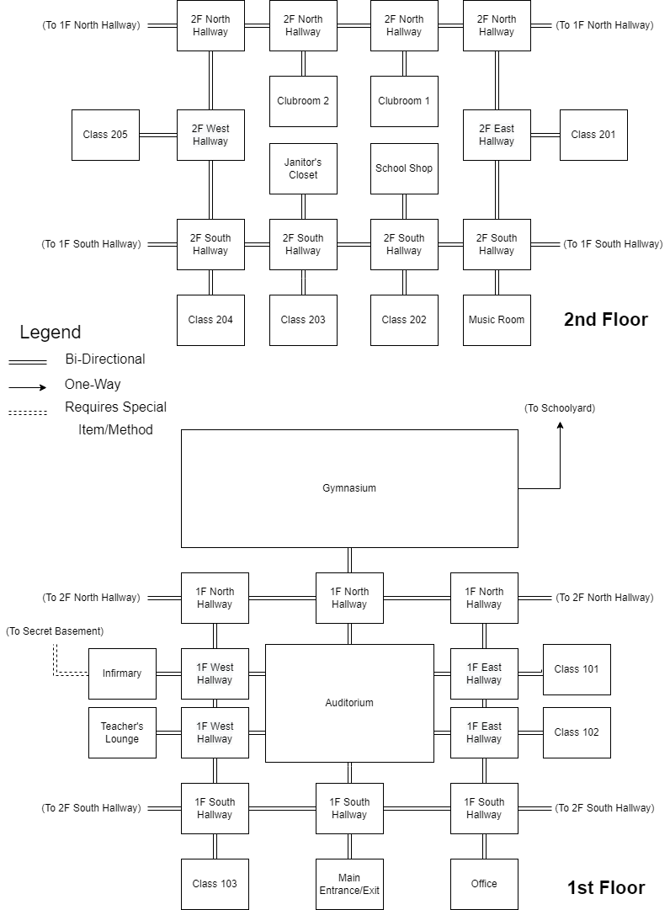

1. Both Asmodeus and Mephistopheles are taken from the Forgotten Realms lore.
2. Taken from the Persona series where a player’s decisions can result in either a Bad, Good, or True Ending